PHASE- 5 : PROJECT DOCUMENTATION AND SUBMISSION.
PUBLIC TRANSPORTATION OPTIMIZATION
IBM: NAAN MUDHALVAN.
GROUP 4 & ZONE 14
MENTOR: K.PRIYANKA M.E.., ASSISTANT PROFESSOR
TEAM MEMBERS: DOMAIN-IOT
        - S.SUBHA DHARSHINI
        - A.VISHNU PRIYA
        - M.PRIYA
        - K.GAYATHRI
        - R.RABIKA

Abstract:
The use of technology such as the Internet of Things (IoT) can make data collecting and analysis easier. This paper presents the design and development of a smart public transport management system (TMS) to increase system capacity and enhance passenger safety and comfort while lowering costs and risks. The proposed system is an electronic device that is placed in a public bus. This device can acquire data from sensors and send it to a cloud server in real-time. The data available on the cloud can be fetched allowing the management to monitor the status of the buses. It will also help commuters plan their trips in an efficient way by tracking the location of the bus. The data can also be analyzed using different analysis and visualization tools. The resultant information can be used to enhance and optimize the services offered by the company. The entire system has been tested thoroughly in real-time and it has proven to function successfully.
Problem statement:
The project involves integrating IoT sensors into public transportation vehicles to monitor ridership, track locations, and predict arrival times. The goal is to provide real-time transit information to the public through a public platform, enhancing the efficiency and quality of public transportation services. This project includes defining objectives, designing the IoT sensor system, developing the real-time transit information platform, and integrating them using IoT technology and Python.
Real time problems:
- Overloaded buses
- Less frequency of buses
- Breakdown of buses (e.g. proper maintenance & BCP)
- Planning and priority on the basis of availability and urgency of the service provision (e.g. traffic system and priority management system integration)
- Accidents by public transport vehicles due to rash driving
Requirements:
- GPS devices
- Wheel speed sensors
- Torque sensors
- Sensors measuring the health of the vehicle
- Basic Infrastructure Requirement:
- Wi-Fi at each bust stop and each bust depot
- Sensors required:
- Fuel level measurement sensors
Basic Infrastructure Requirement:
- Wi-Fi at each bust stop and each bust depot
Sensors required:
- Fuel level measurement sensors
- Fuel flow meters (measures the flow of the meter with the travelled distance)
- Torque Sensors
- Speed measurement sensors
- Air monitoring sensors

IOT Applications in Smart Public Transportation:

IOT (Internet of Things) technology is being used in smart public transportation to improve the overall experience for passengers, optimize public transportation routes, and reduce missions.

Real-Time Passenger Information IOT sensors can be used to provide real-time information to passengers on bus and train schedules, arrival times, and delays, improving the overall passenger experience

Asset Tracking : IOT sensors can be used to monitor public transportation vehicles in real-time, providing data on vehicle locations, maintenance needs, and fuel consumption, which can be used to optimize transportation routes and reduce emissions

Predictive Maintenance : IOT sensors can be used to detect potential issues with public transportation vehicles before they result in downtime, reducing maintenance costs and improving vehicle performance

Demand-Based Routing: IOT technology can be used to collect data on passenger demand for public transportation services, allowing for the optimization of transportation routes and reducing congestion.

Automatic Fare Collection : IOT sensors can be used to collect fares automatically, reducing he need for manual fare collection and improving the overall efficiency of public transportation systems.

Safety Monitoring : IOT sensors can be used to monitor public transportation vehicles and detect potential safety issues, such as speeding or sudden stops, improving the overall safety of public transportation systems.

Objectives:
1. To determine the specific goals of the system, such as improving efficiency, reducing costs, enhancing passenger experience, or reducing environmental impact.
2. To develop a Smart system that could benefit RTC (Road Transport Corporation) as well as the passengers
3. To develop a business model where operator can act as an Enterprise Service Provider
4. To encourage the passenger to use public transport for commuting there by reducing traffic congestion, air pollution etc.
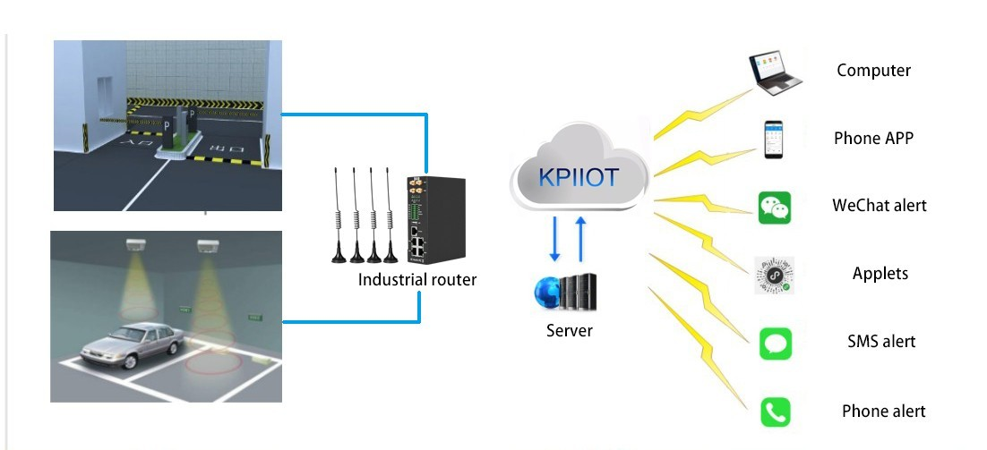
.
Planning and managing the buses:
The basic requirements for the use case is that all the Bus depot are connected to each other and all the small bus stands will be connected to the respective depots of the town. The source depot will update the departure time of the bus to all the bus stands and the destination depot. GPS tracking and tracing systems will provide the information about how far the bus is from the destination and the estimated time of arrival. The number of the passengers waiting at the respective bus stand will be updated frequently

Here, one scenario is discussed where at different times buses will depart from the depot X for the destination depot Y. The route will cover all the bus stops in between and bus timings are already predefined.
• Bus will depart from X depot with 50 vacant seats.
• It will pick up 30 passengers from 1st bus stop then the dashboard at the bus stop will display the information as shown in the below diagram.
• After filling up the seats at the 2nd bus stop the bus will communicate with the bus depot X and also with all the bus stop regarding no vacant seats.
•. Bus depot will make the arrangement of another bus and it will send the notification to all the bus stop about the departure and arrival time of the bus.
• At the same time bus will be notified about the passengers waiting at the 3rd and 4th bus stop.
Here are some IoT innovation ideas for optimizing public transport:

- Smart Ticketing Systems.
- Predictive Maintenance
- Real-time Passenger Information
- Traffic and Congestion Monitoring
- Vehicle Tracking and Fleet Management
- Energy Efficiency
- Safety and Security
- Smart Bus Stops and Shelters
- Demand-Responsive Services
- Passenger Feedback Systems
- Noise and Pollution Monitoring
- Accessibility Enhancements

Optimizing public transport using IoT (Internet of Things) innovations involves collecting real-time data from buses, trains, and other transportation modes to improve efficiency, safety, and passenger experience. Here are some ideas and coding concepts to get you started:

Real-time Tracking and Monitoring:
- Use GPS and sensors to track the location and speed of vehicles.
- Collect data on fuel consumption, engine health, and maintenance needs .Code a dashboard or mobile app to display this data for operators and passengers.
Predictive Maintenance:
- Implement predictive maintenance algorithms to detect and prevent breakdowns.
- Use machine learning to analyze sensor data and predict when maintenance is required.
- Create alerts and maintenance schedules based on the predictive analysis.
Smart Traffic Management:

- Develop algorithms to optimize traffic signals based on real-time traffic flow.
- Use IoT to coordinate traffic lights to reduce congestion and improve bus scheduling.
Passenger Information Systems:
- Build mobile apps or digital signage for real-time bus and train arrival information.
- Use IoT data to estimate arrival times accurately.
- Provide updates on delays or route changes to passengers.
Ticketing and Payments:
- Implement contactless payment systems using IoT-enabled cards or smart phones.
- Create secure, encrypted protocols for processing payments.
- Develop apps for passengers to purchase tickets and check their balances.
Environmental Monitoring:
- Deploy IoT sensors to measure air quality and noise pollution.
- Code systems to display this data to passengers and transportation authorities.
- Use data to optimize routes to minimize environmental impact.
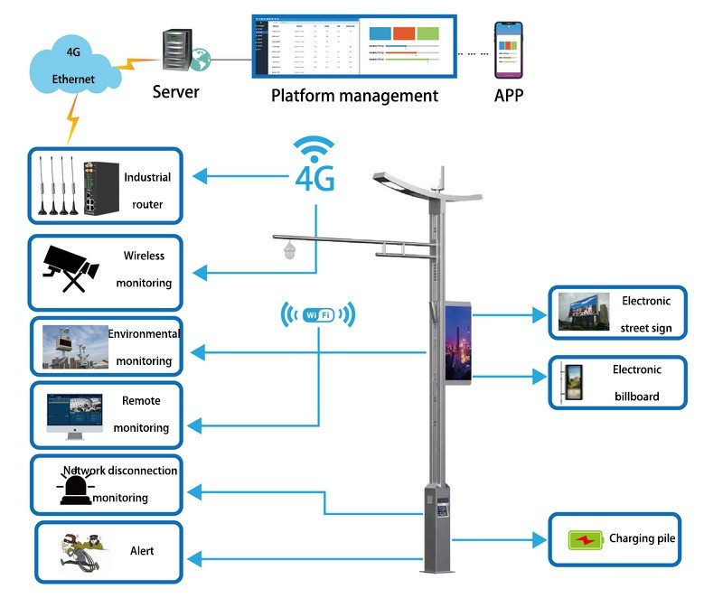

Security and Safety:
- Install surveillance cameras in vehicles and stations for security.
- Develop facial recognition or object detection algorithms for identifying potential threats.
- Code emergency notification systems for passengers and authorities.
Energy Efficiency:
- Use IoT to monitor and optimize energy consumption in vehicles and stations.
- Implement smart lighting and HVAC systems that adjust based on occupancy.
- Develop algorithms to minimize energy waste.
Fleet Management:
- Build a fleet management system to track vehicle availability, maintenance, and scheduling.
- Optimize routes and resource allocation using data-driven insights.
- Automate vehicle assignments and maintenance requests.
Data Analytics and Reporting:
- Develop data analytics pipelines to process and analyze IoT data.
- Create reports and visualizations to identify trends and make data-driven decisions.
- Implement machine learning models for demand forecasting and route optimization.
- Remember to prioritize data security and privacy, as IoT systems often involve sensitive information. Additionally, consider scalability and reliability in your coding efforts to ensure the long-term success of your public transport optimization project.
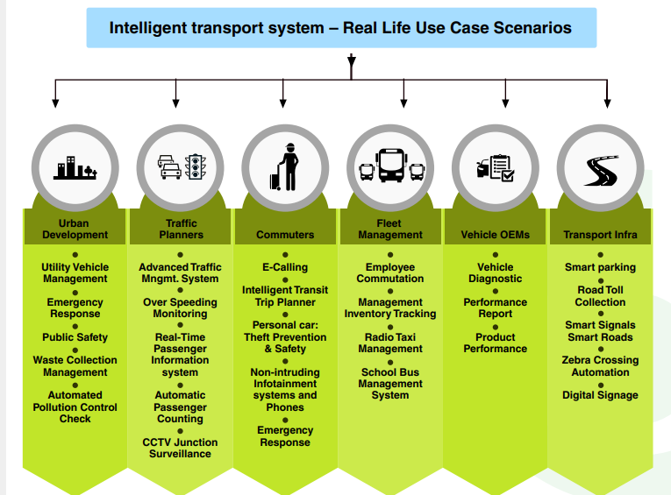

HARDWARE SELECTION:
- Choose suitable I0T devices (sensors, GPS modules, RFID/NFC readers, etc.) to collect data from buses, trains, and stations.
- Select appropriate communication protocols (like MQTT, CoAP) and network connectivity options (Wi-Fi, cellular, LoRa) for data transmission.
Data Collection and Sensors:
Install Sensors:
Equip vehicles with sensors to collect data such as location, speed, fuel consumption, passenger count, and environmental conditions.
Station Sensors:
Implement sensors at stations for passenger count, occupancy, and environmental monitoring.
Data Storage:
Set up a secure and scalable database to store the collected data.
RFID SENSOR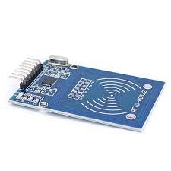
Incorporating machine learning algorithms to improve arrival time prediction accuracy based on historical data and traffic conditions is a valuable and practical use case for enhancing transportation and logistics systems. Here's a step-by-step approach to implementing such a system:
- Data Collection and Pre-processing:
  - Gather historical data: Collect data on past trips, including start and end times, routes taken, traffic conditions , and any other relevant factors (weather, road closures, special events, etc.).
  - Real-time data: Integrate real-time data sources such as traffic cameras, GPS data, and weather forecasts to provide up-to-the-minute information.
  - Data pre-processing: Clean and pre-process the data, handling missing values and outliers, and converting categorical variables into numerical formats.
- Feature Engineering:
  - Extract relevant features: Create features from the data that can be used for prediction, such as time of day, day of the week, road type, historical traffic congestion patterns, and more.
  - Feature selection: Use techniques like feature importance analysis or dimensionality reduction to select the most informative features.
- Model Selection:
  - Choose appropriate machine learning algorithms for regression or time series forecasting. Common choices include:
    - Linear Regression
    - Random Forest Regression
    - Gradient Boosting (e.g., Boost, Light)
    - Recurrent Neural Networks (RNNs) or Long Short-Term Memory (LSTM) networks for sequence data.
  - Experiment with different models and hyper parameters to find the best-performing one.
- Training and Validation:
  - Split the data into training, validation, and test sets.
  - Train the machine learning model on the training data and validate its performance on the validation set.
  - Use metrics like Mean Absolute Error (MAE), Mean Squared Error (MSE), or Root Mean Squared Error (RMSE) to evaluate the model's accuracy.
- Hyper parameter Tuning:
  - Fine-tune the model's hyper parameters using techniques like grid search or Bayesian optimization to optimize its performance.
- Real-time Prediction:
  - Deploy the trained model to make real-time predictions for upcoming trips. Integrate it with the transportation system to provide accurate arrival time estimates to users.
- Continuous Monitoring and Retraining:
  - Regularly update the model with new data to adapt to changing traffic patterns and conditions.
  - Monitor the model's performance and retrain it as needed to maintain accuracy.
- User Feedback Integration:
  - Collect feedback from users about the accuracy of the predictions.
  - Use this feedback to further improve the model and address any issues or discrepancies.
- Scalability and Deployment:
  - Ensure that the system can handle a high volume of prediction requests, especially during peak traffic times.
  - Consider cloud-based solutions for scalability and reliability.
- Privacy and Data Security:
  - Implement robust data security and privacy measures to protect sensitive information, such as user locations and trip histories.
- Regulatory Compliance:
  - Ensure that the system complies with local regulations and data protection laws, especially when dealing with user data.
By following these steps, you can create a robust machine learning-based arrival time prediction system that continually improves its accuracy and provides valuable information to users for better trip planning and transportation management.

FLOW CHART:
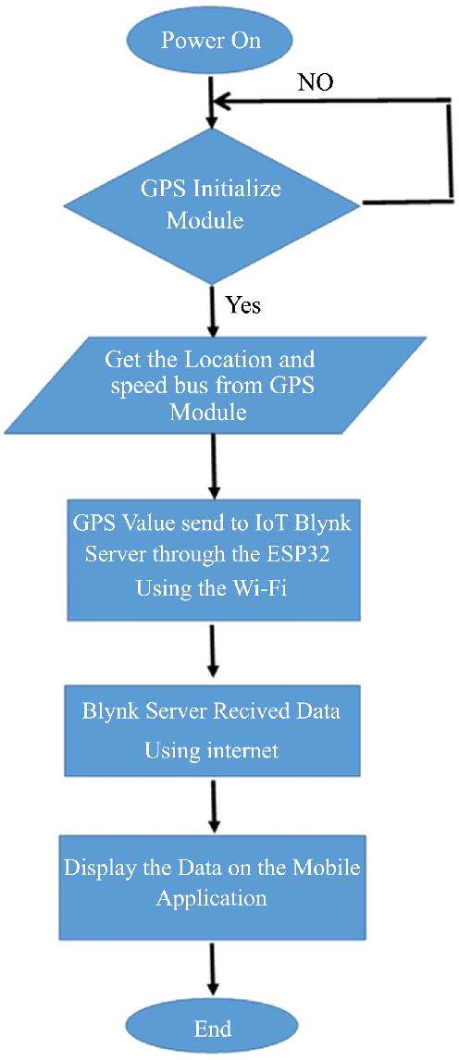
Communication Infrastructure:
Implement middleware for communication between IoT devices and the central server.
Ensure real-time transmission of data from vehicles and stations to the central system.
Cloud Platform:
Choose a reliable cloud service provider (AWS, Azure, Google Cloud) for hosting the backend infrastructure.
Data Processing:
Implement data processing mechanisms to analyze and make sense of the raw data collected from sensors.
Big Data and Analytics:
Utilize big data analytics tools to gain insights from large datasets, enabling predictive maintenance and route optimization.
Mobile and Web Applications:
Passenger App:
Develop a user-friendly mobile app for passengers to access real-time information, plan routes, and receive updates about delays or disruptions.
Admin Dashboard:
Create a web-based dashboard for transportation agencies to monitor the fleet, analyze data, and make informed decisions.
Predictive Analytics and AI:
Implement predictive maintenance algorithms to foresee maintenance needs and prevent breakdowns.
Use machine learning models to predict demand, optimize routes, and enhance scheduling efficiency.
Employ IoT-enabled GPS tracking to monitor the location of public transport vehicles, ensuring efficient deployment and better coordination during peak hours.
Energy Efficiency:
Implement IoT sensors to monitor and control the energy consumption of public transport vehicles, reducing environmental impact and operational costs.
Safety and Security:
Install IoT-based surveillance systems inside vehicles and at stations to enhance passenger safety and deter criminal activities
Smart Bus Stops and Shelters:
Create smart bus stops and shelters equipped with IoT sensors, offering Wi-Fi connectivity, weather updates, and charging stations for passengers.
Demand-Responsive Services:
Develop IoT-powered algorithms that adapt public transport routes and schedules based on real-time demand data, optimizing resources and reducing empty trips.
Passenger Feedback Systems:
Collect feedback from passengers through IoT-enabled kiosks or mobile apps to continuously improve public transport services based on user input.
Noise and Pollution Monitoring:
Use IoT sensors to measure noise levels and air quality around public transport routes, enabling authorities to take measures to reduce pollution and noise pollution.
Accessibility Enhancements:
Implement IoT solutions to assist passengers with disabilities, such as automatic ramps and doors, audible announcements, and real-time accessibility information.
These IoT innovations can help enhance the efficiency, safety, and convenience of public transport systems while reducing their environmental impact.
Data Collection:
Gather historical data on routes, including timestamps of past journeys, traffic conditions, weather, and any other relevant information that may affect travel times.
Data Preprocessing:
Clean and preprocess the data to handle missing values, outliers, and inconsistencies. Feature engineering can also be essential to extract relevant information from the raw data.
Model Selection:
Choose machine learning algorithms suitable for time series data and regression tasks. Common choices include Linear Regression, Random Forest, Gradient Boosting, and more advanced models like Long Short-Term Memory (LSTM) networks for deep learning.
Feature Selection:
Identify the most important features that impact arrival times and use them as inputs to your model. Feature selection techniques like feature importance scores or recursive feature elimination can help.
Model Training: Split the data into training and testing sets to evaluate model performance. Train your chosen algorithm on the training data and fine-tune hyper parameters to optimize performance.
Validation and Testing:
Evaluate the model's accuracy and performance using the testing dataset. You can use metrics like Mean Absolute Error (MAE) or Root Mean Squared Error (RMSE) to measure prediction accuracy.
Real-time Data Integration:
Incorporate real-time data sources, such as traffic updates, into your model for more accurate predictions. APIs from services like Google Maps or Waze can be valuable for this purpose.
Deployment:
Once satisfied with the model's performance, deploy it as a service or integrate it into your navigation app. Ensure it can handle continuous updates and adapt to changing traffic conditions.
Continuous Learning:
Implement mechanisms for model retraining and updates to account for changing traffic patterns and new data. This ensures your predictions remain accurate over time.
User Feedback: Collect user feedback to further improve your model and incorporate user suggestions or corrections into the prediction system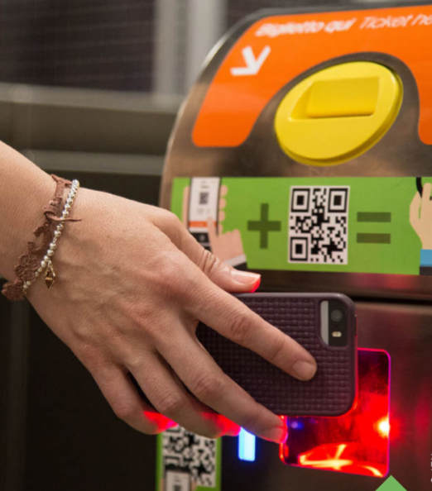
Data Encryption:
Ensure end-to-end encryption of data to maintain its confidentiality and integrity.
Access Control:
Implement robust access control mechanisms to restrict unauthorized access to sensitive data.
Maintenance and Updates:
Establish a system for regular maintenance, including software updates, security patches, and hardware checks.
Collect feedback from users and transportation staff to continuously improve the system based on real-world usage and experiences.
Compliance and Regulations:
Ensure that the system complies with local transportation regulations, data protection laws, and privacy standards.
Selecting Sensors and Devices:
GPS Sensors: Choose GPS modules that are accurate and provide real-time location data. GPS modules with integrated antennas and motion sensors are commonly used.
Passenger Counters: There are various types available, including infrared sensors, ultrasonic sensors, and weight sensors. Choose one that suits the type of public transportation vehicle and accuracy requirements.
Power Supply:
Ensure that the sensors are powered by the vehicle's electrical system. You might need to install voltage regulators or other power management devices to ensure stable power supply.Implement a backup power source, like rechargeable batteries, to keep the sensors running in case of power fluctuations or vehicle shutdowns.
Sensor Placement:
GPS Sensors:
Install GPS sensors on the vehicle's roof or another location with a clear view of the sky to ensure optimal satellite signal reception.
Passenger Counters:
Place passenger counters strategically near vehicle entrances and exits, ensuring they cover all boarding and alighting points.
Data Transmission:
Communication Protocols:
Choose suitable communication protocols such as cellular networks (3G/4G/5G), Wi-Fi, or LoRaWAN for transmitting data from sensors to the central server.
Data Security:
Implement encryption and other security measures to protect the data transmitted from sensors to the server.
Data Processing and Storage:
Edge Computing:
Consider implementing edge computing to process data locally within the vehicle. This can reduce latency and bandwidth usage by sending only relevant data to the central server.
Cloud Storage:
Store the collected data securely in a cloud-based database. Cloud platforms like AWS, Azure, or Google Cloud offer scalable and reliable storage solutions.
Real-time Monitoring and Analytics:
Develop a real-time monitoring dashboard for transportation operators to track vehicle locations, passenger counts, and other relevant data.
Implement analytics tools to process the data and generate insights, helping in route optimization, scheduling, and demand forecasting.
Calibration:
Calibrate passenger counters regularly to maintain accuracy, especially if they rely on technologies like infrared or ultrasonic sensors.
Stay updated with advancements in sensor technologies. Plan for future sensor upgrades or additions to enhance data accuracy and gather more detailed information.
To send real-time location and ridership data from IoT sensors to a transit information platform, you can create a Python script that collects data from sensors and sends it to the platform using HTTP requests or MQTT (Message Queuing Telemetry Transport protocols.
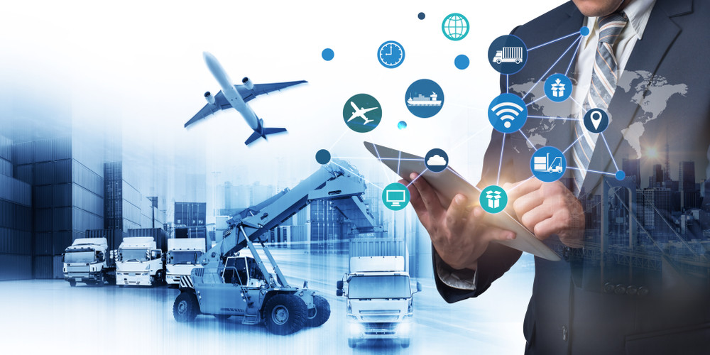
PROGRAM:
import time
import random
class Bus:
def __init__(self, bus_id, route):
self.bus_id = bus_id
self.route = route
self.current_location = None
defupdate_location(self):
# Simulate IoT device data
latitude = random.uniform(35.0, 36.0)
longitude = random.uniform(-90.0, -89.0)
self.current_location = (latitude, longitude)
defget_location(self):
return self.current_location
class Passenger:
def __init__(self, passenger_id):
self.passenger_id = passenger_id
class SmartTransportationSystem:
def __init__(self):
self.buses = []
self.passengers = []
defadd_bus(self, bus_id, route):
bus = Bus(bus_id, route)
self.buses.append(bus)
defadd_passenger(self, passenger_id):
passenger = Passenger(passenger_id)
self.passengers.append(passenger)

deftrack_buses(self):
while True:
for bus in self.buses:
bus.update_location()
print(f"Bus {bus.bus_id} - Location: {bus.get_location()}")
time.sleep(10) # Simulate updates every 10 seconds
if __name__ == "__main__":
transportation_system = SmartTransportationSystem()
# Add buses and passengers
transportation_system.add_bus(1, "Route A")
transportation_system.add_bus(2, "Route B")
transportation_system.add_passenger(1)
transportation_system.add_passenger(2)
# Start tracking buses (simulated IoT updates)
transportation_system.track_buses()
Creating a real-time transit information platform involves several steps. Here's a high-level outline of what you should consider:
Define Requirements:
Clearly define the requirements for your platform. What kind of transit information do you want to display? What IoT sensors will you be using, and how will they transmit data?
Select IoT Sensors:
Choose appropriate IoT sensors for collecting real-time data. These could include GPS sensors for location, passenger counters for ridership, and sensors on vehicles for arrival time information.
Data Collection and Transmission:
Set up a system to collect data from the IoT sensors. This often involves using microcontrollers or IoT platforms to transmit data to a central server.
Database:
Create a database to store the real-time data. You may use technologies like MySQL, MongoDB, or others, depending on your specific needs.
Web Development:
Build the web platform using HTML, CSS, and JavaScript. You can use frameworks like React, Angular, or Vue.js for a more dynamic interface.
Real-Time Updates:
Implement mechanisms like WebSockets or Server-Sent Events to enable real-time updates on your platform.
Data Visualization:
Use libraries like D3.js or Chart.js to create visually appealing displays for location, ridership, and arrival time data.
User Interface:
Design an intuitive user interface that allows users to interact with the data easily. Consider mobile responsiveness for users on different devices.
Security:
Ensure data security and user privacy by implementing authentication and authorization mechanisms.
Testing:
Rigorously test the platform to identify and fix any bugs or performance issues.
Deployment:
Deploy your platform to a web server. Consider using cloud platforms like AWS, Azure, or Heroku for scalability.
Maintenance:
Continuously monitor and maintain the platform to ensure it remains functional and up-to-date.
Documentation:
Create user and developer documentation to guide users and future developers working on the project.
Remember to adapt the above steps to your specific project's needs and size. Developing a real-time transit information platform is a complex task, so consider the scale and resources available for your project.
SCHEMATIC DIAGRAM:
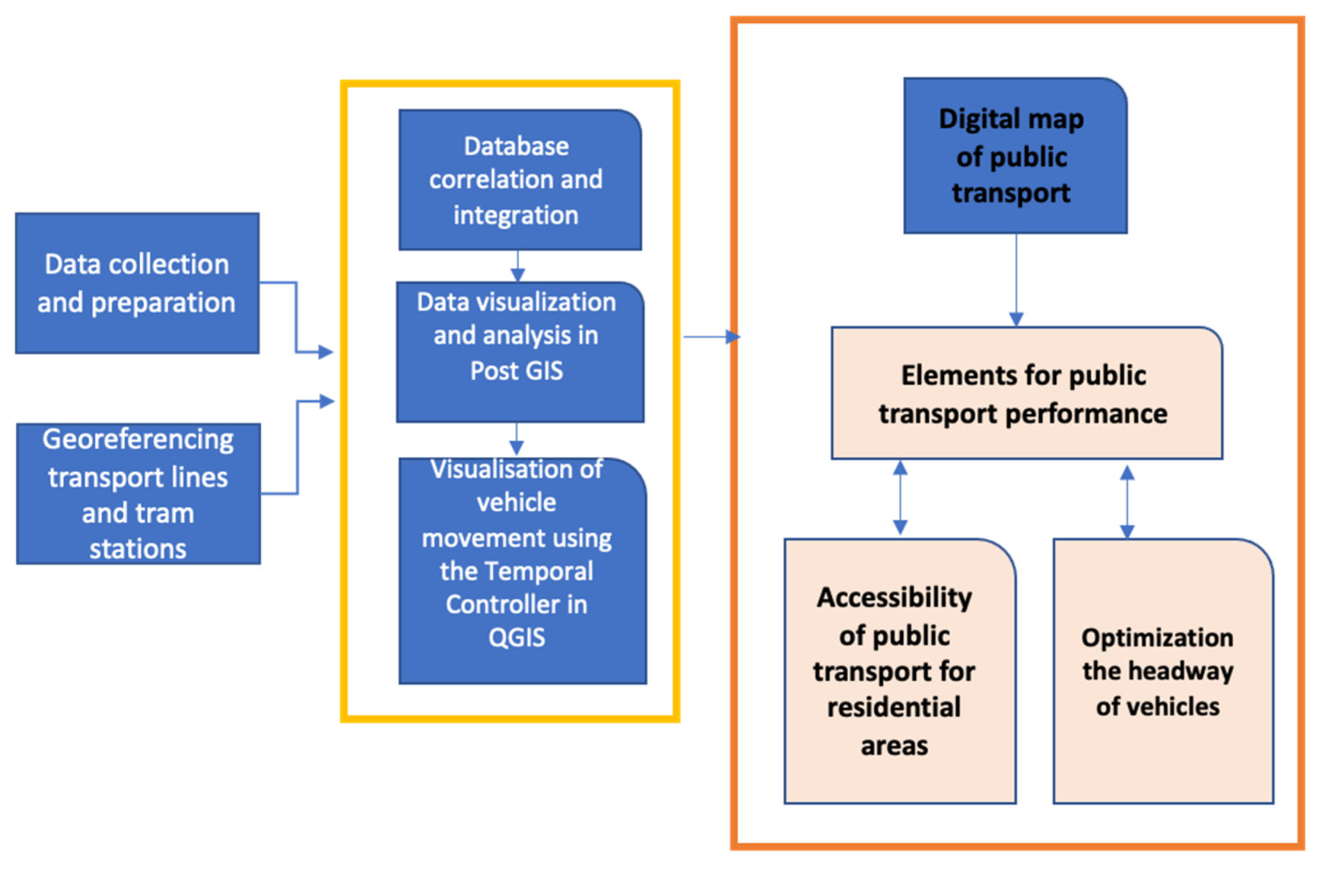

Here's a basic example of a web development technologies(i.e., html , cssjavascript)
Html:
<!DOCTYPE html>
<html lang="en">
<head>
<meta charset="UTF-8">
<meta name="viewport" content="width=device-width, initial-scale=1.0">
<link rel="stylesheet" href="styles.css">
<title>Smart Public Transportation</title>
</head>
<body>
<div class="container">
<h1>Smart Public Transportation System</h1>
<label for="routes">Select Route:</label>
<select id="routes">
<option value="Route1">Route 1</option>
<option value="Route2">Route 2</option>
</select><br>
<label for="busStops">Select Bus Stop:</label>
<select id="busStops">
<option value="StopA">Stop A</option>
<option value="StopB">Stop B</option>
<option value="StopC">Stop C</option>
<option value="StopD">Stop D</option>
</select><br>
<button onclick="findNextBus()">Find Next Bus</button>
<p id="result"></p>
</div>
<script src="script.js"></script>
</body>
</html>
Css:
body {
font-family: Arial, sans-serif;
}
container {
max-width: 300px;
margin: 0 auto;
text-align: center;
padding: 20px;
border: 1px solid #ccc;
border-radius: 10px;
margin-top: 50px;
}
button {
margin-top: 10px;
cursor: pointer;
}
Javascript:
functionfindNextBus() {
constselectedRoute = document.getElementById("routes").value;
constselectedStop = document.getElementById("busStops").value;
const routes = {
"Route1": ["StopA", "StopB", "StopC", "StopD"],
"Route2": ["StopD", "StopC", "StopB", "StopA"]
};
const stops = routes[selectedRoute];
constcurrentIndex = stops.indexOf(selectedStop);
constnextStopIndex = (currentIndex + 1) % stops.length;
constnextStop = stops[nextStopIndex];
const result = `Next bus on ${selectedRoute} will arrive at ${nextStop}.`;
document.getElementById("result").textContent = result;
}
Output:
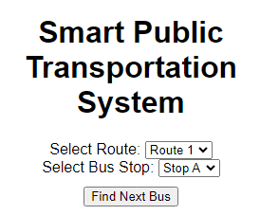
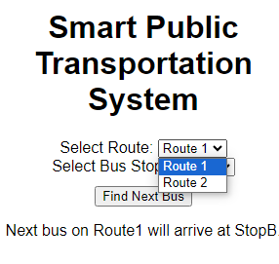
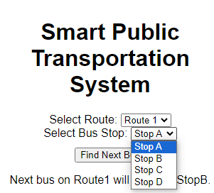

Designing a public transport optimization platform to receive and display real-time location, ridership, and arrival time data from IoT sensors involves several components. Here's a high-level architectural overview of how such a system could be designed:
IoT Sensors:
Deploy IoT sensors on public transport vehicles (buses, trams, trains) to collect data. These sensors should capture:
Real-time location: GPS data to track the vehicle's position.
Ridership data: Passenger counting sensors, such as weight sensors or infrared sensors.
Arrival time data: Sensors at stops to detect when a vehicle arrives or departs.
Data Collection and Processing:
Set up a centralized data collection system to receive data from IoT sensors in real-time.
Process and filter the incoming data to extract relevant information, such as vehicle ID, location, passenger counts, and timestamps.
Data Storage:
Store the processed data in a database system. You might use a database management system like PostgreSQL or a NoSQL database, depending on the scale and complexity of your project.
API and Backend:
Develop a backend system with APIs to:
Receive data from the IoT sensors and update the database.
Provide access to real-time data for external services and the front-end.
Front-End Interface:
Create a user-friendly web interface using HTML, CSS, and JavaScript to display the real-time information to users.
Use JavaScript libraries for mapping and data visualization (e.g., Leaflet, D3.js).
Real-Time Data Display:
On the front end, continuously request and display data from the backend API to show real-time vehicle locations on a map.
Display current ridership data and vehicle arrival times for specific stops.
Route Planning and Optimization:
Implement algorithms for route planning and optimization, using the real-time data to recommend optimal routes and transit options.
User Features:
Allow users to search for routes, set preferences, and receive alerts for delays or changes.
Display historical data and trends in ridership and on-time performance.
Here's a basic example of a web page that allows users to select their starting and ending points for a public transport route:
html
<!DOCTYPE html>
<html>
<head>
<title>Public Transport Optimization</title>
<style>
/* Add your CSS styles here */
body {
font-family: Arial, sans-serif;
}
</style>
</head>
<body>
<h1>Public Transport Optimization</h1>
<form>
<label for="start">Starting Point:</label>
<input type="text" id="start" placeholder="Enter starting point">
<label for="end">Ending Point:</label>
<input type="text" id="end" placeholder="Enter ending point">

<button onclick="optimizeRoute()">Optimize Route</button>
</form>
<div id="result">
<!-- Display optimization results here -->
</div>
<script>
functionoptimizeRoute() {
// Add your JavaScript logic for route optimization here
// You would need to make API calls, implement algorithms, and display the optimized route.
// This is a simplified example, and the actual logic can be quite complex.
document.getElementById('result').innerHTML = 'Optimized route goes here';
}
</script>
</body>
</html>

Output:
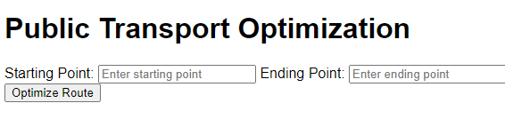
EXAMPLE:
<!DOCTYPE html>
<html>
<head>
<title>Public Transport Optimization</title>
</head>
<body>
<h1>Public Transport Optimization Example</h1>

<h2>Bus Routes</h2>
<ul>
<li>Route 1: Stops - A, B, C, D</li>
<li>Route 2: Stops - D, E, F, G</li>
<!-- Add more routes and stops as needed -->
</ul>

<h2>Train Routes</h2>
<ul>
<li>Line A: Stations - Station 1, Station 2, Station 3</li>
<li>Line B: Stations - Station 3, Station 4, Station 5</li>
<!-- Add more train lines and stations as needed -->
</ul>

<h2>Optimization Results</h2>
<p>Optimized routes and schedules could be displayed here.</p>

<!-- You can add JavaScript for interactivity and further optimization -->

</body>
</html>
OUTPUT:
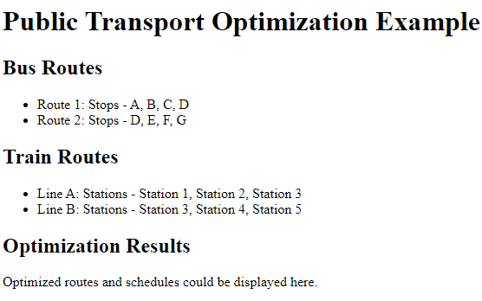
Python code:
Import random
# Constants
POPULATION_SIZE = 10
MUTATION_RATE = 0.1
GENERATIONS = 100
# Sample data (can be replaced with real data)
bus_stops = [(1, 1), (2, 2), (3, 3), (4, 4), (5, 5)]
bus_routes = [[0, 1, 2, 3, 4], [4, 3, 2, 1, 0]] # Sample initial routes
# Function to calculate the total travel time for a bus route
defcalculate_total_time(route):
total_time = 0
for i in range(len(route) - 1):
total_time += abs(bus_stops[route[i]][0] - bus_stops[route[i + 1]][0]) + abs(
bus_stops[route[i]][1] - bus_stops[route[i + 1]][1]
)
return total_time
# Genetic Algorithm
defgenetic_algorithm():
population = [bus_routes] * POPULATION_SIZE
for generation in range(GENERATIONS):
population = sorted(population, key=lambda x: calculate_total_time(x))
fittest = population[0]
new_population = [fittest]
for _ in range(POPULATION_SIZE - 1):
parent1 = random.choice(population[: POPULATION_SIZE // 2])
parent2 = random.choice(population[: POPULATION_SIZE // 2])
child = []
for i in range(len(bus_stops)):
if random.random() < MUTATION_RATE:
child.append(random.randint(0, len(bus_stops) - 1))
else:
if random.random() < 0.5:
child.append(parent1[i])
else:
child.append(parent2[i])
new_population.append(child)
population = new_population
return sorted(population, key=lambda x: calculate_total_time(x))[0]
# Run the Genetic Algorithm and print optimized routes
optimized_routes = genetic_algorithm()
for i, route in enumerate(optimized_routes):
print(f"Bus {i + 1} Route: {route}")

long get_distance1() {
// Start a new measurement:
digitalWrite(PIN_TRIG1, HIGH);
delayMicroseconds(10);
digitalWrite(PIN_TRIG1, LOW);

// Read the result:
duration1 = pulseIn(PIN_ECHO1, HIGH);
distance1 = duration1 / 58;
return distance
}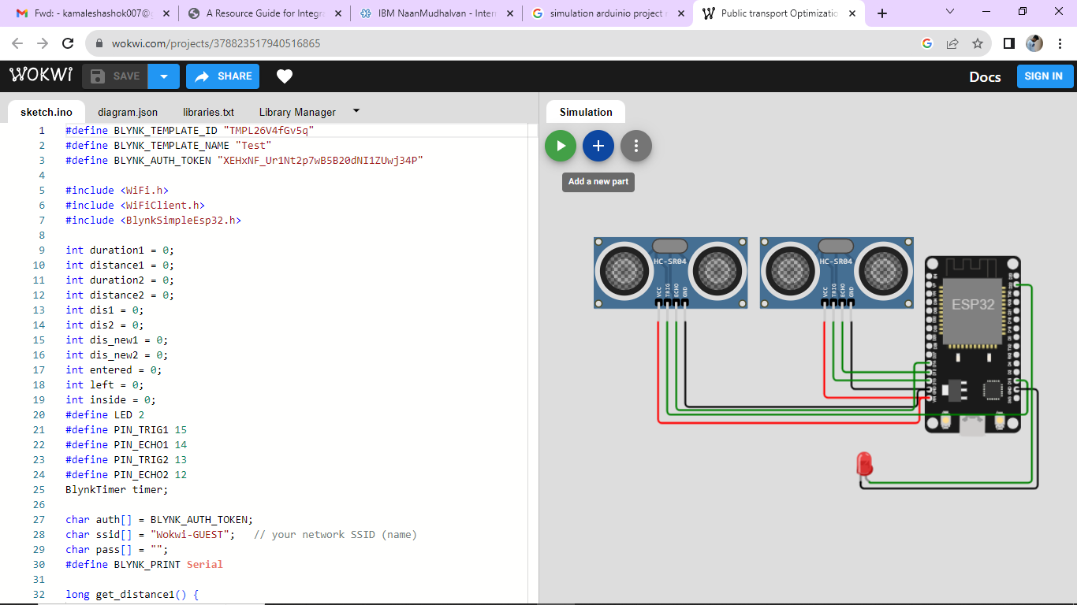

CONCLUSION:
In conclusion ,mathematical optimization can be help public transport system especially in large cities ,overcome their existing challenges and unlock next level business growth.
Public transport system is far more efficient and environment friendly for cities than means of personal transport. It can be difficult at first for people to stop using their cars ,but as a result will be better for everyone.

